EXPORT THE ANALYTICS

|  |  |
| --- | --- |
| Team ID | PNT2022TMID20305 |
| Project Name | Estimate The Crop Yield Using Data Analytics |

Finally, it's to share your work either through email/link/pdf to showcase your works to others.

# STEP: 1

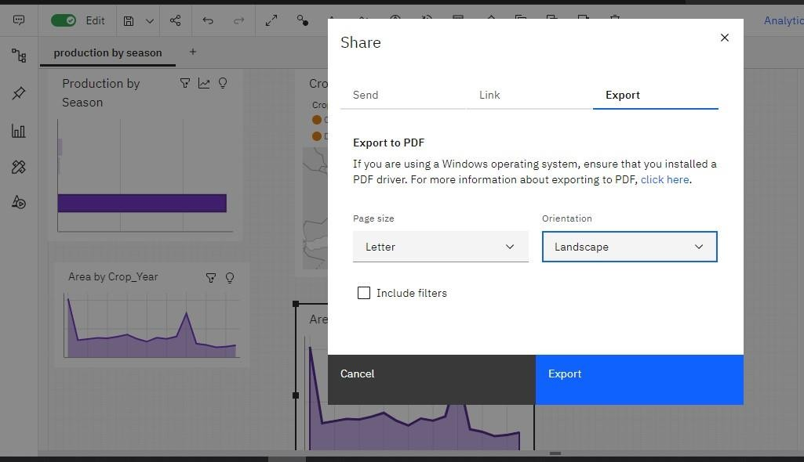

**STEP: 2**

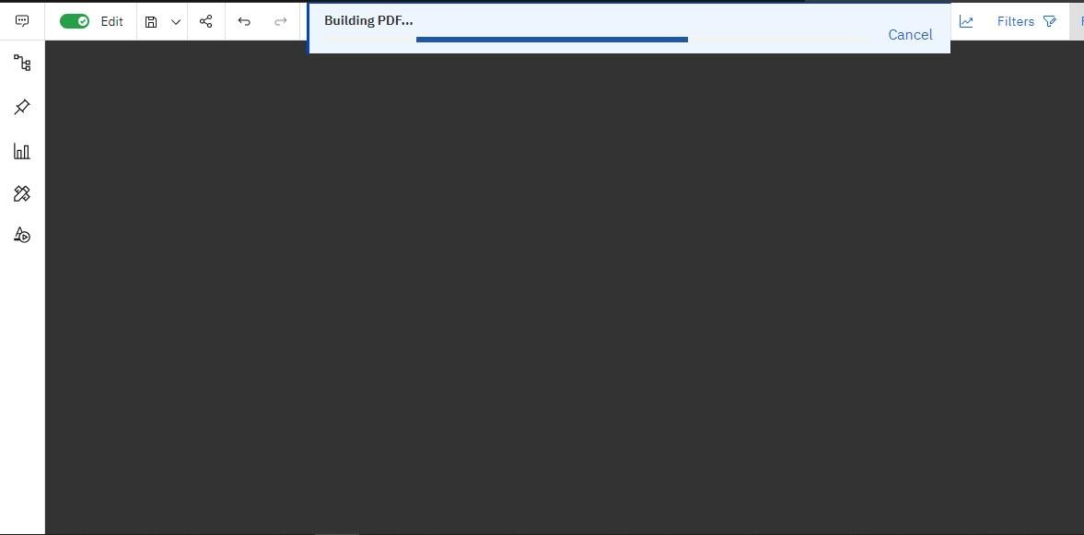

**STEP: 3**

